ME400 Capstone Design

Part 1. Review of Progress

Our team thoroughly divided labors. After short brainstorming of robot concept thinking about how it will operate, all the other things needed to realize that idea are done by SOLIDWORKS part. However, because of uncertainty of SOLIDWORKS part’s liability SOLIDWORKS parts started to discuss about configuration design after two to three weeks after the brainstorming. Progress report 1 and 2 explains the result of SOLIDWORKS part’s initial configuration design of our system. The original STL file for 2nd progress report was used in our team’s first presentation slide.

After finishing the configuration design, we started to decided actual dimensions for each parts. It was very laborious job. I and Hamza tried to minimize the system size. So we changed a bit of operating mechanism as scooping rather than sweeping. But by doing so, we should to consider the squeezing problem of front scooper. If the bottom or ramp forms acute angle when the ball is scooped by front scooper, it may result in stuck of motors and will cause breakdown of that. The result of our consideration for dimensions is explained in Progress report 3 and 6.

Finishing rough decision for dimensions, SOLIDWORKS part started to make actual robots. It spent a whole week. But anyway we could finish making basic frames our robot until the midterm exam. Progress report 4 and 5 shows the actual frames of our robot at that time.

After the midterm I and Hamza 3d printed may parts such as ramp, scooper, door, electronic mount, etc. Progress report 7, 8, and 9 shows actual printed things or STL file needed to print them. An week before second presentation SOLIDWORKS part finished making first robot which can operate for actual job if the ROS part enters an instruction.

But the robot has some mechanical problems. The biggest one was stuck of the ball at the front ramp. I realized me and Hamza considered only acute angle made by scooper and bottom. So I tried to redesign the frontal scooper, and finally made it before final presentation. The second biggest problem was ROS parts abrupt demand that we need to make our robots push away the red balls from the direction of progress of robot. This demand was given two weeks before. I and Hamza tried many other solutions even before the day of final presentation. Fortunately, after some try and error, I could find the solution. But the solution was somewhat weird. It seemed to contradict our insight. By attaching a slant guide at frontal ramp I thought the ball will be forced out along the direction of normal vector of that plane, however the ball moved toward the other way, it seemed to trace up slanted wall! I thought the phenomenon is occurred because the ball’s gravity center is at away from the center of sphere. However, I couldn’t assure teammates so they tried to use analogy of conveyer belt. That analogy is used in final presentation slide.

Part 2. Set of Progress reports.

1st Progress Report: Team 1 SOLIDWORKS part, 20150469 HuiMan, Yang

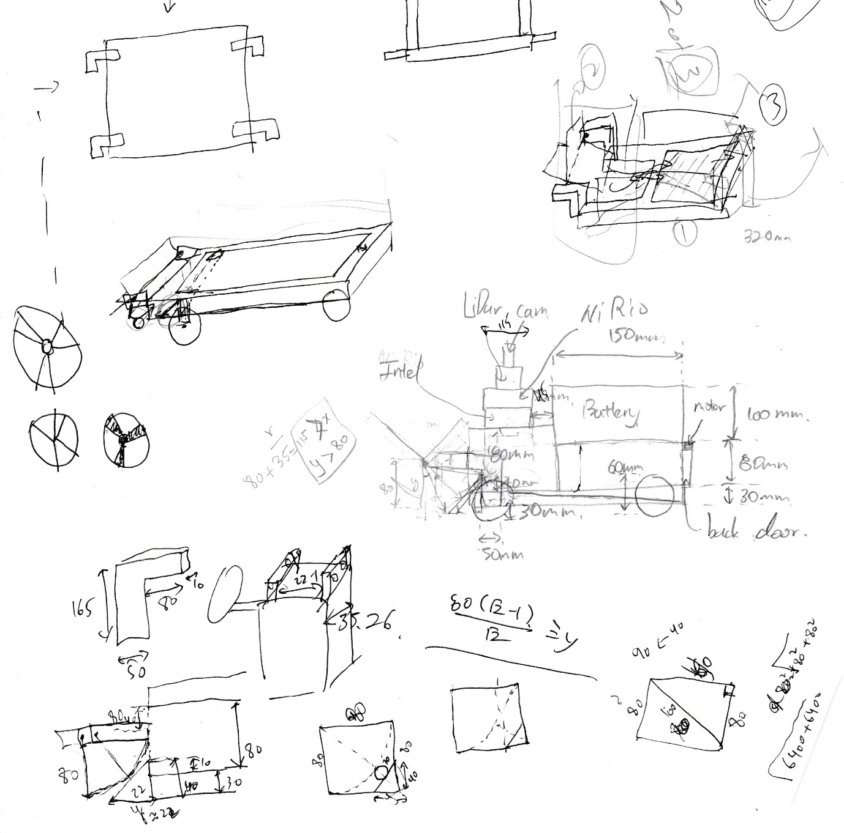

Me and Hamza who taking care of SOLIDWORKS part did some rough sketch of our robot which is based on the roller-type pick-up method. There are some assumed dimensions, which will be considered and replaced later, like the thickness of the plates or columns, etc.

2nd Progress Report: Team1 SOLIDWORKS part, 20150469 HuiMan, Yang

Based on rough sketch drawn before week, me and Hamza formulated it by using 3D CAD tool; SOLIDWORKS. The results of drawing are presented below.

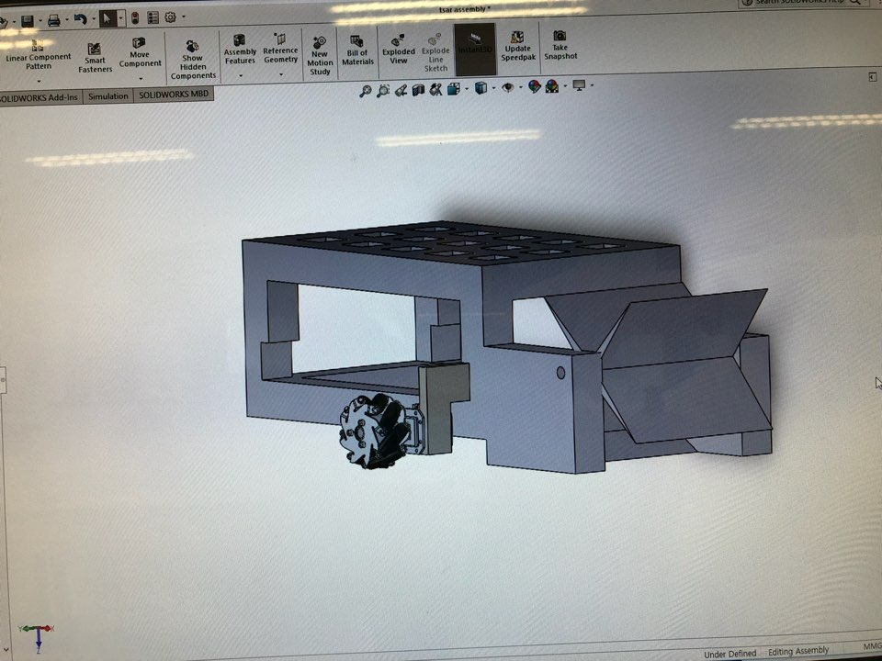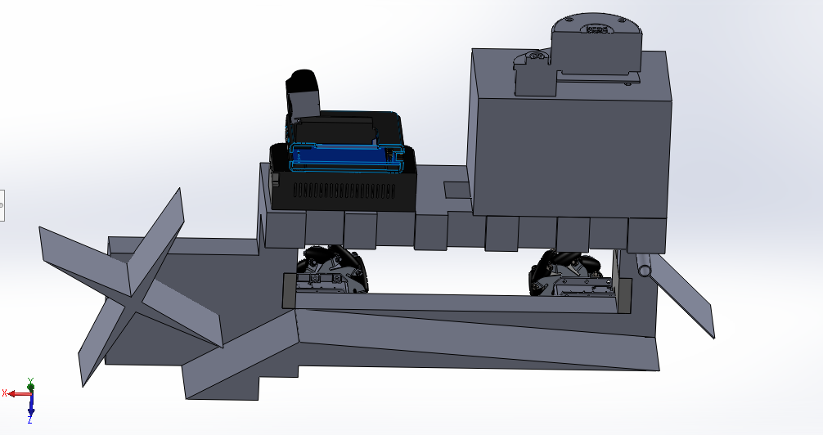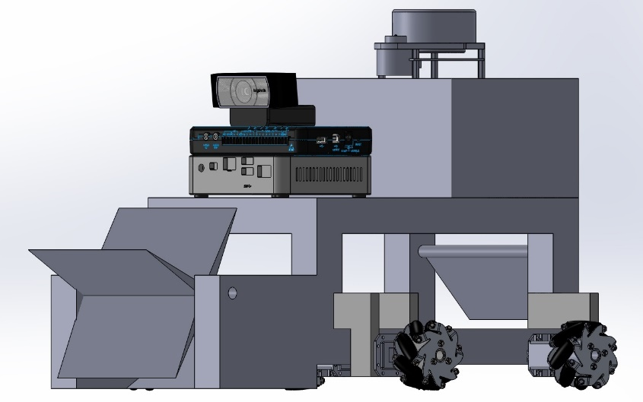

3nd Progress Report: Team1 SOLIDWORKS part, 20150469 HuiMan, Yang

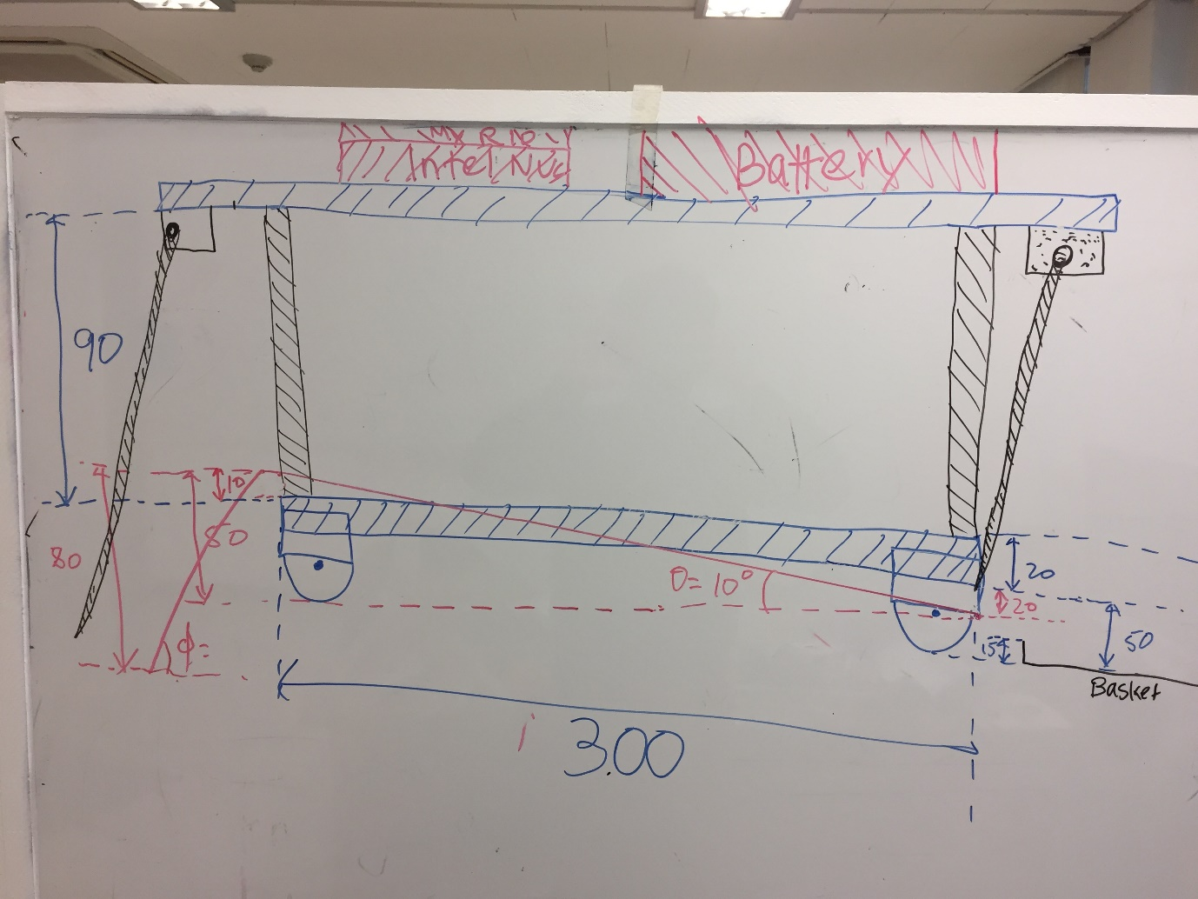To make our product more simply, we changed our design slightly. The result is given above. Then later, we discussed and assessed different materials for our robot frame. Using a 20mm x 20mm Aluminum Profile for the purpose is thought as the simplest and satisfactory choice. It was easy to handle, cut and join. This gives us flexibility in manufacturing and eases the design process.

4th Progress Report: Team1 SOLIDWORKS part, 20150469 HuiMan, Yang

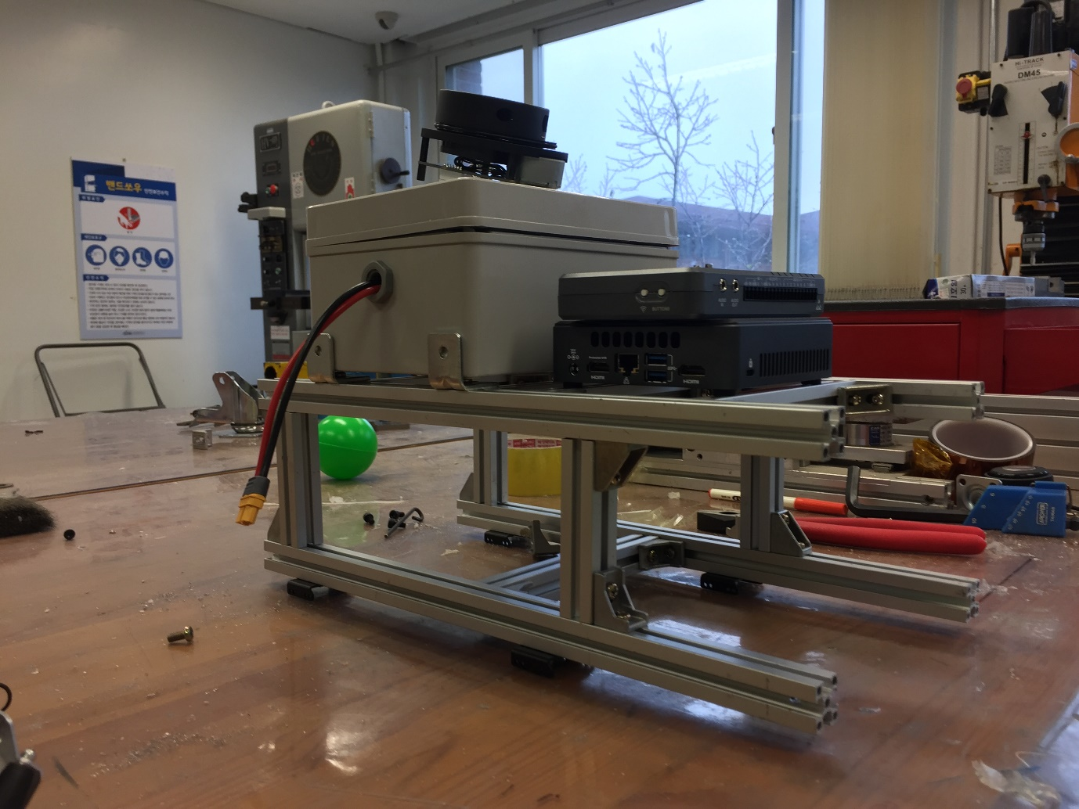Moving on from the determination of the principle dimensions we actually took upon the task of making the robot frame using the 20x20 Aluminum Profiles. We cut, filed and assembled the different pieces together with nut and bolts to finally get the robot frame shown in the figure below. To make the robot frame horizontal was a big problem. We should pay attention to fine tune before it actually taking the task.

5th Progress Report: Team1 SOLIDWORKS part, 20150469 HuiMan, Yang

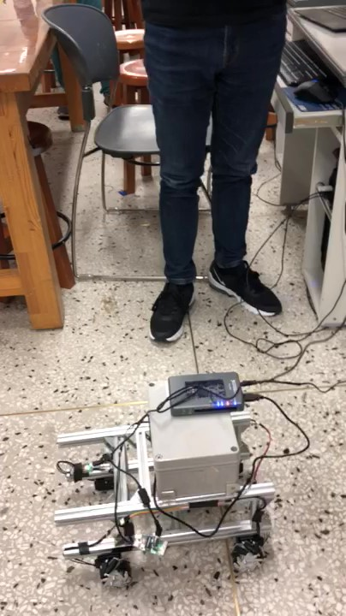

With the help of LAPVIEW coworkers we attached the Swedish wheel and checked whether it works well. Fortunately, the robot moves smoothly and it didn’t show any problems like severe vibration. So we finally finished to make our robots driving system. Later, unless other implicit problems being noticed, the driving system will not change significantly.

6th Progress Report: Team1 SOLIDWORKS part, 20150469 HuiMan, Yang

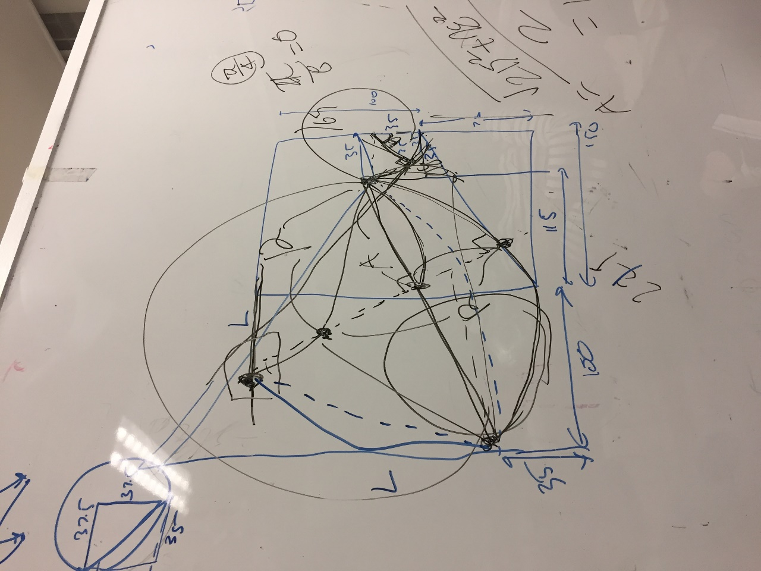

Concerning SOLIDWORKS TAs advice, we decided to make our sweeper design robust. Previously, we just concerned the case only the ball is at the edged position of front ramp. But obviously the balls can be anywhere near the front ramp because there always exists some error in position of robot even if we carefully adjust robots motion algorithm. Hence to give more ease to ROS coworkers we redesigned the sweeper design can sweep a ball which is slightly apart from the frontal ramp. Now we finished drawing to print the sweeper by 3D printer.

7th Progress Report: Team1 SOLIDWORKS part, 20150469 HuiMan, Yang

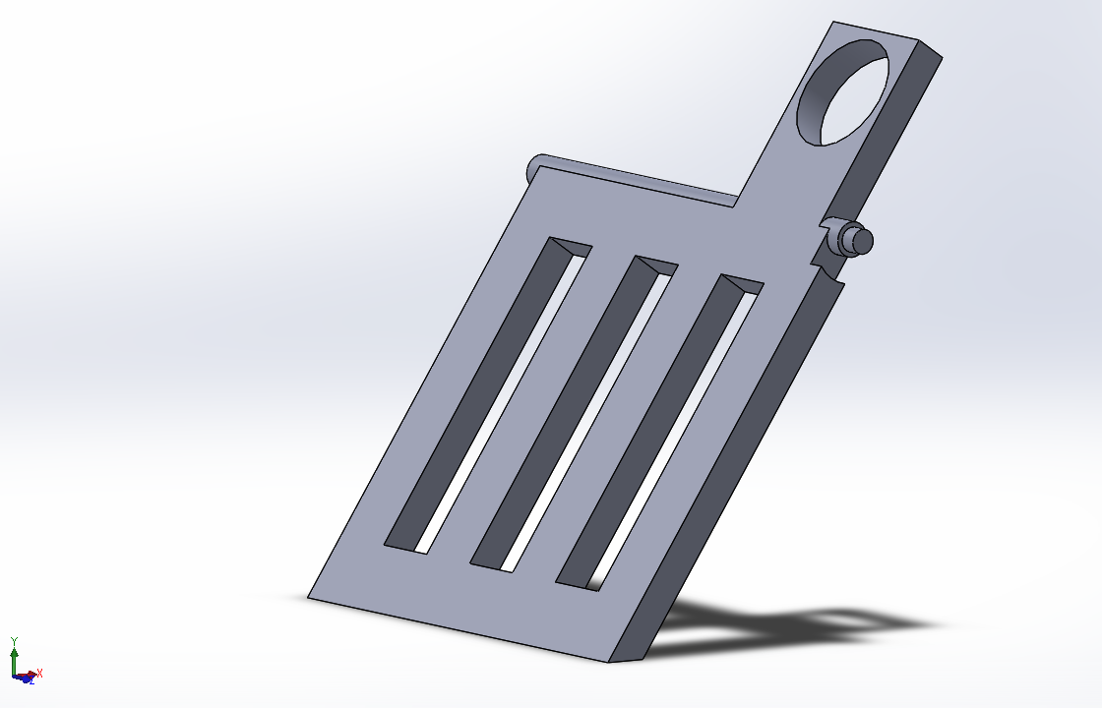For the robustness of entire design, we redesigned the front sweeper. Introducing hollow structure, we reduced the total mass of sweeper. Furthermore, to prevent sweeper squeezing the ball we differed the tip material as softer own. The last evolution of our design is the existence of counter mass to reduce the stationary-torque which occurs the sweeper is at stationary.

8th Progress Report: Team1 SOLIDWORKS part, 20150469 HuiMan, Yang

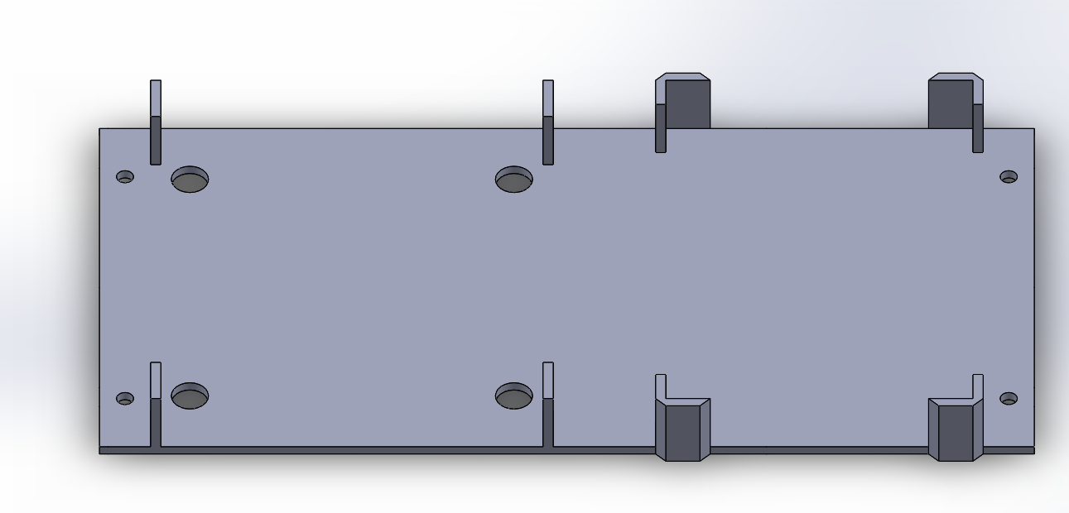

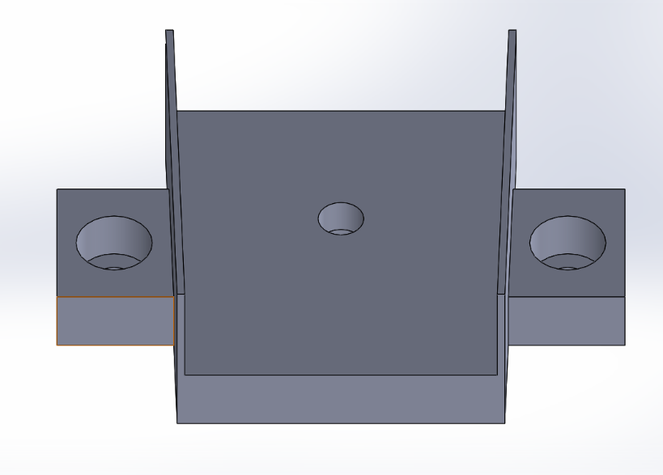

We made mounts for electronics. The first figure shows mounts for NUC and My Lio. The second one is for camera. The important figure of our mounts is it is easily decomposed, since we wouldn’t use any adhesives. So in later change of our configuration, we will not have no problem for reusing the electorinics.

9th Progress Report: Team 1 SOLIDWORKS part, 20150469 HuiMan, Yang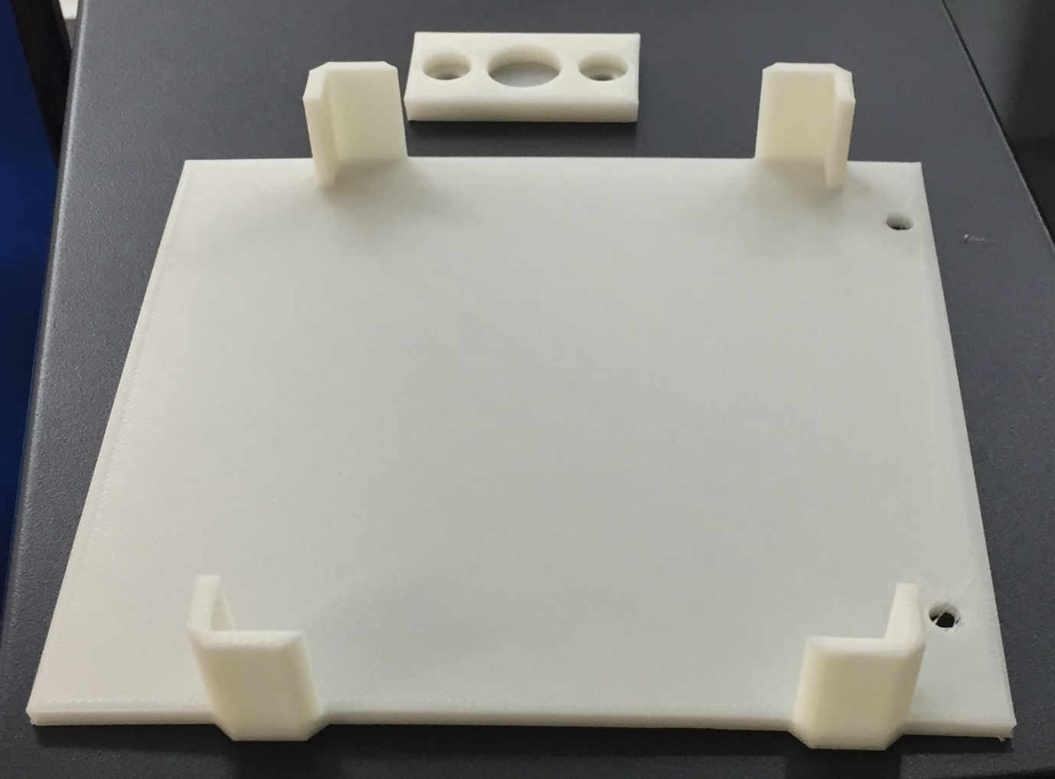

To make our robots electronics be at desired position, we produced electronic mounts for NUC, MYLIO, Web cam, ISO, and bread board. Above picture shows the mount for MYLIO and bearing bracket. For other devices we chosen similar strategy to fix the position of electronics.

10th Progress Report: Team 1 SOLIDWORKS part, 20150469 HuiMan, Yang

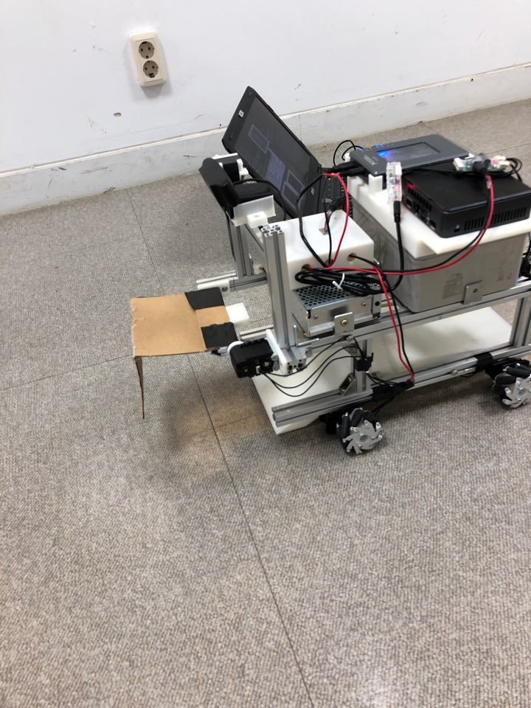

Very important issue was arisen. Our previous sweeper design was nor proper. Actually, we tried to design the sweeper and ramp make obtuse angle when the sweeper sweeps the ball at the tip position of ramp. Unfortunately, we gave to small angled tip to previous sweeper, so we couldn’t achieve our purpose. So we tried rapidly to make the system work in desired fashion. We will 3D print the front sweeper shown above picture.

Part 3. General Review.

Dividing labors thoroughly. It seemed attractable for exhausted students about team project. But I could learn this strategy is very bad for engineers. The lack of communication of our team was the very cause of our failure; we just but two balls rather three balls, even finally it results discord with other teammates. If there is another chance to work with in a team, I will try to increase the amount of discussion itself of teammates. It was very nice chance to learn about what do I need to work with others. I appreciate this class.